**BDM Capstone Project Document for 2024 students**

This document has been prepared jointly by **Dr. Aaditya Chandel and Dr. Ashwin J. Baliga**. All have contributed equally towards the preparation of this document.

Do go through all the live sessions, FAQs, documents, and the reference books, to facilitate better understanding.

Any report submitted **without name and or roll number is desk rejected**!

Every submission should strictly adhere to the rubrics. If it doesn’t adhere to it, you end up losing marks. Format and structure your reports the way we have done here.

We would prefer **Times New Roman 12, 1.5 spacing and left/ right justification of fonts**. Also, you need to ensure that the report is written well and do not mix active/ passive voice. Project is not just showing data set and graphs. A good report should explain all the elements in a very neat manner. Using commas and full stops wherever possible. Also, ensure you connect one section with the next. There must be a connection when you move from one paragraph to the next.

Every project should have a title and it should look professional and at the same time communicate what it intends to.

**Sample Titles**:

1. Optimizing the Customer Support Workflow of an E-Learning Programme
2. Price Prediction and Demand Forecasting for an Industrial Scrap Trading Company

The titles are extremely important because this catches the reader’s interest. Do not write calculating the profits for a Idli Vada Shop, Increasing performance of ABC company etc! This would really look weird at first glance.

Now once this is done, the second step is to write an **executive summary**

An executive summary tells the reader what the key points in the report are. It includes the following: purpose of the report, major points, brief descriptions of the results/ conclusions/ recommendations. So essentially, you write an executive summary of the business for which you are doing this project.

Never say I will find loopholes and help increase the firm’s sale! You can never solve all the problems. Remember the solution you give is always a small drop in the ocean. You can always mention that this project will enable the organization to identify the bottlenecks and the solutions provided would help them tackle a few of the issue(s).

The next thing is to provide information on the **background of the company**

Mention about the company and its inception, the founders, net worth, more about the organization structure, what are the offerings (products/ services), number of employees, locations they are into, the mission and the vision statement (if available) etc.

The third step is to **clearly define the problem statement**

You will uncover this upon discussion with the owner(s). Do not directly ask them as to what their problem is. It’s a step-by-step process.

Be polite (give a firm shake hand, request for permission to speak/ sit/ make notes). Be empathetic (Introduce yourself) and then be professional (set the agenda as to why you are meeting them). Ask more about their offerings and then about the situation of the industry, followed by the problem. Check as to what they have done to resolve the same and if unresolved the reasons for it. As you follow this process and ask good open-ended probing questions, you are likely to arrive at your problem statement.

Mention the objectives. This should be in line with the problem statement.

**Sample Objectives**

1. To improve the efficiency of the existing system in closing customer requests.
2. To determine the important strategies that contribute to relationship building in business markets.

In objectives, never state as to how you will resolve the problem. It is the objectives that determine the methodology and not the other way round.

Once this is done provide information on how you plan to collect the data. This is referred to as

**Data collection process.**

What kind of data you would collect?

Essentially the data collected should be in line with the problem statement/ objectives.

Let us say, the firm is facing constant stockouts. In this case, you will require details on the following: Opening stock, closing stock, Buying Price, Selling Price, Demand, Forecast, EOQ, Lead time and many other variables.

Once you get sufficient variables, you decide what to do/ plot, in line with the problem statement/ objectives. Don’t draw Pareto charts. Generally, owners are aware of 20% issues🡪 80% problems.

Some sample graphs (Always name them, since it’s for illustration I haven’t named it)

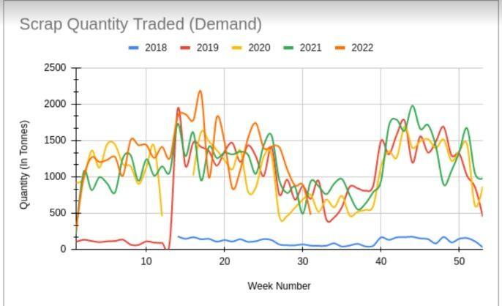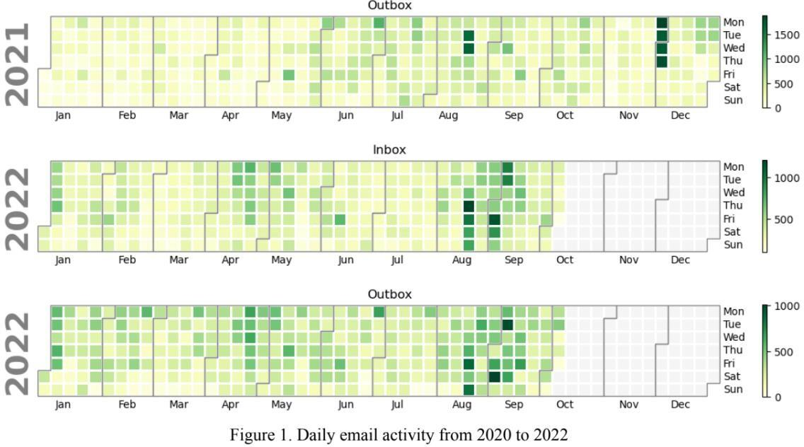

Graph Source: Student projects from Term 2, Cherian Varghese, and Jaidev Deshpande

**Expected timelines**

Timelines should be explained using Work Breakdown structure (WBS) and a Gantt Chart. Every project task is defined using WBS and Gantt Chart tells the timelines for tasks defined in the WBS. **If this is missed, the report is desk rejected!**

A simple search online will help you understand this. Typically, in this section you breakdown your jobs and tell the reader what and when you will accomplish the tasks. In this case your project. For instance, data collection- 2months (mention dates), final submission (3 months) and give a breakup of work you intend to do.

Sample WBS, Source : Internet

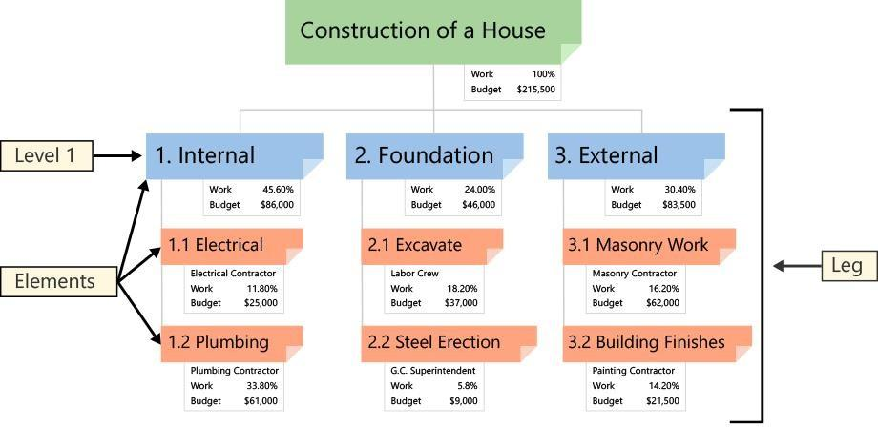

Sample Gantt Chart, Source: Internet

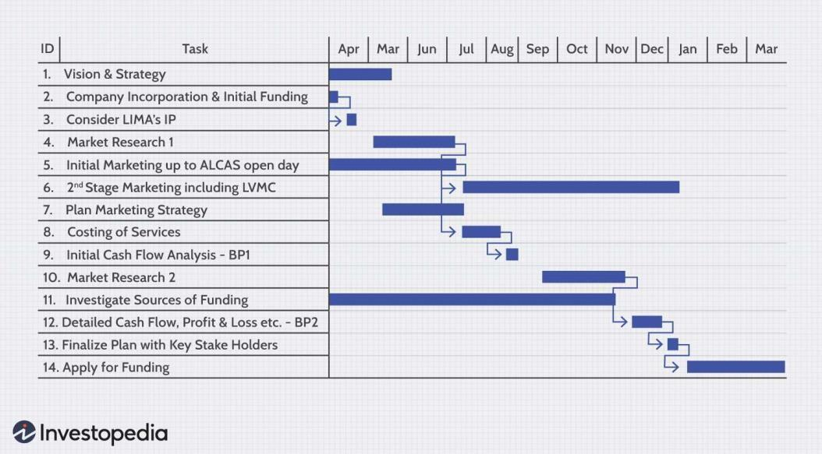

**Expected outcomes**

Here you mention what deliverables would be provided. The likely implications/ insights you expect from the project.

Remember that these insights should come from the graphs, which you have done based on analyzing data and not by intuition.

Am sure this will help you in your submissions. Projects we expect you to go back and have a look at all resources we have shared and then attempt.

Merely drawing graphs, pareto and poor writing doesn’t serve the purpose. We wish you all the best.

**Note:**

1. Graphical analysis should be provided from the mid-term and is not needed during the proposal stage. Kindly adhere strictly to rubrics to avoid desk rejection.
2. All the documents (irrespective of the stage), need to have page numbers, figure, and table numbers wherever applicable. Also, do indicate figure and table numbers in the text write up.
3. Applicable from midterm- Justify the rationale for drawing a particular graph. Spikes like bar chart and simple pareto do not add much value. Do refer to the graphical plotting pdf document shared, to get more ideas on what to plot and why!
4. There are no separate documents prepared for mid term and final. Students should use this as reference and prepare mid-term and final submissions.
5. We strongly recommend that you read the reference books that we have shared. This will enhance your understanding.

----------End of the report----------

This document has been jointly prepared by Dr. Aaditya Chandel and Dr. Ashwin Baliga. It has been prepared for learning purposes and cannot be shared en masse without the permission of the undersigned.

BDM Capstone Project- Analysis with Primary Data

1. The student needs to collect the data pertaining to a business problem. It could be any business- organized or unorganized sector. E.g.: Manufacturing, automobile, IT sectors, supermarkets, laundry, vegetable vendors, restaurants, service businesses etc. Kindly note that only “**primary data**” is to be collected. **Do not collect**data from online sources like Kaggle, GitHub etc., as they constitute the secondary data sources. **This is an independent research project.**
2. Clearly explain the process of data collection.
3. Prepare field notes describing the meeting between the two parties (Student and the business, the people involved etc.). Mention in brief, how many meetings were done and what was discussed?
4. Understanding of the business (Type of Business-B2B, B2C or both) and nature of problem(s) the businesses encounter.
5. How do businesses solve the problems they encounter? Are these problems recurring or one-time?
6. How did the student narrow down the problem?
7. How was the data collection done? Time period of data collection (Days/ Months/Years etc.).
8. Tangible evidence (People, Processes (say an organization chart) or any form of physical evidence)
9. Details about the various variables collected as a part of data collection. Importance of these variables and their relevance.
10. Cleaning of the data – Describe the process in brief and how it was done.
11. Analysis of the data- While the students can use the case studies taught in BDM course as cues to conduct the analysis, the rationale for the same needs to be mentioned. We also encourage students to go through newspapers, journals, reference books, use learnings from other courses etc, and explore newer ways of conducting analysis.
12. Provide insights from the analysis conducted to the businesses.
13. What should businesses do? (Continue doing and start doing)
14. What is that they need to avoid?
15. In what ways do your solution(s) address the business problem(s)?

Kindly note these insights should be novel, as something that adds value to the decision maker. The insights should be derived from the analysis you conduct. So, the better the data, the richer the insights!

Flow of Project

Submission Phases and Evaluation criteria

1. Proposal submission- Scaled down to 20%
2. Mid-term Submission (Explanation of Data collection and cleaning) - Scaled down to 20%
3. Final Submission with Analysis/Interpretation of data - Scaled down to 40%
4. Viva Voce- Scaled down to 20%

Students must make the submissions only via the project portal,  [https://bdmcapstonefrontend.firebaseapp.com/login](https://www.google.com/url?q=https://bdmcapstonefrontend.firebaseapp.com/login&sa=D&source=editors&ust=1734242412122977&usg=AOvVaw35hWKUukEWHn_vfXbLhN4G) .  Submissions via email will not be accepted.

Timeline for 2024 term students

(These are tentative dates; it may vary based on student submission)

Note: Suppose you submit the proposal between July 1-5, the results for the same will be announced on July 10th. The mid-term submission can happen only in Aug 6-10 and results will be announced by 15th August. Final submission from September 11th to 15th and results for this would be announced on 20th September.

Viva can be given in the same month.

Kindly note, the students take 3-6 months on average to complete the BDM Capstone project. Excellent projects are shortlisted and will be awarded certificates. The students also get an opportunity to present their work to senior industry professionals.

Link: [https://www.youtube.com/watch?v=m5iGcEWi8L4](https://www.google.com/url?q=https://www.youtube.com/watch?v%3Dm5iGcEWi8L4&sa=D&source=editors&ust=1734242412124393&usg=AOvVaw1L99L09yRAuXK6tqDnbuT3) (BDM Best Capstone Project)

BDM Prior session links: [https://www.youtube.com/@bdmpod6038/streams](https://www.google.com/url?q=https://www.youtube.com/@bdmpod6038/streams&sa=D&source=editors&ust=1734242412124703&usg=AOvVaw2vRB6UcEe48Zb85S-1NDqA) (This has sessions wherein senior students presented their projects)

Live session by Dr. Aaditya Chandel- Usually conducted every Sunday ([https://youtu.be/HSVXWbXoDW8](https://www.google.com/url?q=https://youtu.be/HSVXWbXoDW8&sa=D&source=editors&ust=1734242412125002&usg=AOvVaw2HjeYMVIy6urfjRAFMXKXD))

The declaration statement is a must while submitting the proposal. Submissions made without it will be desk rejected. The template for the same is available in the drive link shared. It is only to be submitted at the start of the project.

All queries related to payments and registrations be only sent to [support@study.iitm.ac.in.](mailto:sindhuja@study.iitm.ac.in)

We will not be responding to such requests on discourse or via email.

Queries related to project be marked both to [aaditya@study.iitm.ac.in](mailto:aaditya@study.iitm.ac.in) and [ashwin@study.iitm.ac.in](mailto:ashwin@study.iitm.ac.in)

Before sending emails make sure you have gone through all the documents shared and attended live sessions.

|  |  |  |  |  |  |  |
| --- | --- | --- | --- | --- | --- | --- |
| **Proposal submission** | **Announcement of results** | **Mid-term submissions** | **Announcement of results** | **Final submissions** | **Announcement of results** | **Viva Voce** |
| 1st to 5th of every month | On 10th | 6th to 10th of every month | On 15th | 11th to 15th of every month | On 20th | 25th onwards |

Project Proposal

* Proposal must be about four – five pages long
* Proposal is evaluated for 100 marks and scaled down to 20
* A pass mark of at least 50/100 is needed for the proposal to be approved
* At least 2 objectives (problem objectives) must be identified in the proposal, 1 objective is also

acceptable if it’s broad.

|  |  |  |
| --- | --- | --- |
| **a)** | Absence of declaration statement= Desk rejection | Reject Proposal |
| 1 | Does the Proposal discuss a) business problem and or b) plagiarism is less than 20%? | Yes/No |
| 2 | If Answer to Q1 is a “No” | Reject Proposal |
|  | **Expected Contents** | **Weightage** |
| 3 | * Executive Summary and Title (200-250 Words) | 15 |
| 4 | * Organization Background (150-200 Words) | 10 |
| 5 | * Problem Statement (Listed as objectives) (100-120 Words) * Pointwise and not in paragraphs | 10 |
| 6 | * Background of the Problem (200-250Words) | 10 |
| 7 | * Problem Solving Approach (400 Words) | 45 |
| 7a | * Details about the methods used with Justification |  |
| 7b | * Details about the intended data collection with Justification |  |
| 7c | * Details about the analysis tools with Justification |  |
| 8 | * Expected Timeline- Work Breakdown Structure and Gantt Chart | 5 |
| 9 | * Expected Outcome | 5 |

Do refer to the BDM Capstone Project Document for 2024- for short notes on the contents for proposal.

There are no separate documents for mid-term and final.

Mid-term Submission

* Submission must be about 8 – 10 pages long
* Submission is evaluated for 100 marks and scaled down to 20

|  |  |  |
| --- | --- | --- |
| 1 | Is the plagiarism % of the document is less than 20% | Yes |
| 2 | If Answer to Q1 is No | Reject  Submission |
|  | **Expected Contents** | **Weightage** |
| 3 | * Executive Summary and Title (200-250 Words) | 15 |
| 4 | * Proof of originality of the Data (Primary Data - survey link, photograph, letter from organization, etc.) * Letter from organization in letter head with stamp and sign * Images of the firm/ servicescape (Max of 5) * A short video 3-8 mins interacting with the founder | 10 |
| 5 | * Metadata- 20 marks * Descriptive Statistics- 20 marks | 40 |
| 6 | * Detailed Explanation of Analysis Process/Method- justification for its usage. Why is this method more appropriate than the rest | 25 |
| 7 | * Results and Findings (Graphs and other Pictorial Representation Preferred and with words) * Clearly explaining the trends, what and why patterns that has been observed in the analysis | 10 |

Link for metadata and descriptive statistics: Need to justify and link with the problem statement

1. [https://dataedo.com/kb/data-glossary/what-is-metadata](https://www.google.com/url?q=https://dataedo.com/kb/data-glossary/what-is-metadata&sa=D&source=editors&ust=1734242412144743&usg=AOvVaw3LrwV_9KWRmDmLByXsByHt)
2. [https://www.investopedia.com/terms/d/descriptive_statistics.asp](https://www.google.com/url?q=https://www.investopedia.com/terms/d/descriptive_statistics.asp&sa=D&source=editors&ust=1734242412144931&usg=AOvVaw1OIcrBbr5ss0x0VkUt9VWx)

Note:

1. Students might see that some sections are similar (for instance, executive summary, results, and findings etc.) across submissions. These things get refined as and when you navigate through various stages of the submission process.
2. Do not make similar submissions for mid-term and final. While mid-term submission has preliminary results, the final submission is a complete report and thus has higher weightage. Same submissions will attract rejections.
3. Video interaction is a must to establish credibility. It can be in any language. If there are many videos and pictures that you wish to share, you insert it as a drive link and give us access.

Final Submission

* Submission must be about 18 – 20 pages long
* Submission is evaluated for 100 marks and scaled down to 40
* A cumulative score of 40/80 is needed to be eligible for viva voce.

|  |  |  |
| --- | --- | --- |
| 1 | Is the plagiarism % of the document is less than 20% | Yes |
| 2 | If Answer to Q1 is No | Reject  Submission |
|  | **Expected Contents** | **Weightage** |
| 3 | * Executive Summary and Title (200-250 Words) | 15 |
| 4 | * Detailed Explanation of Analysis Process/Method | 15 |
| 5 | * Results and Findings (Graphs and other Pictorial Representation Preferred and with words) | 40 |
| 6 | * Interpretation of Results and Recommendation | 20 |
|  | * Presentation and legibility of the report | 10 |

* Students are free to use any analysis tool including Excel, R, Python etc.

Viva Voce

* Student should present the project using Ppt – Max 10 slides, all inclusive
* Submission is evaluated for 100 marks and scaled down to 20
* A cumulative of 50/100 marks is needed to pass BDM capstone project course
* The presentation should only include things in brief and highlight key findings and results

|  |  |  |
| --- | --- | --- |
|  | **Evaluation Criteria** | **Weightage** |
| 1 | * Presentation Content | 30 |
| 2 | * Presentation Quality | 10 |
| 3 | * Presentation Flow | 10 |
| 4 | * Presenter Communication Skills | 20 |
| 5 | * Presenter ability to answer questions | 20 |
| 6 | * Presenter’s preparedness and confidence | 10 |

Reference Textbooks (**Strongly recommended, worth having in your personal library**)

1. Malhotra, N., & Dash, S. (2019). *Marketing research: An applied approach*. Pearson.
2. Newbold, P. (2013). *Statistics for business and economics*. Pearson.
3. Wirtz, J., & Lovelock, C. (2021). *Services marketing: People, technology, strategy*. World Scientific.
4. Operations Management: Processes and supply chain | Twelfth Edition by Lee J Krajewski and others

----------End of the report----------

This document has been jointly prepared by Dr. Aaditya Chandel and Dr. Ashwin Baliga. It has been prepared for learning purposes and cannot be shared en masse without the permission of the undersigned.

**BDM Capstone Project- Analysis with Secondary Data**

The BDM Capstone project is an independent project, in which the student approaches a business (structured/ unstructured and B2B/B2C/ both) and identifies the problem(s) they face. Post that, data is collected pertaining to the problem(s), which is followed by analysis and providing recommendations/novel insights to the business owner(s).

Projects are where the learning is put to test, and it gives students an opportunity to test their understanding. Students who have completed this successfully have benefitted and it has helped them secure internship opportunities and jobs. The project has received excellent feedback from the students.

Best Capstone Projects: https://www.youtube.com/live/m5iGcEWi8L4?si=A2xJ_Eva5pKsg0CJ

While we strongly recommend you do the BDM Capstone project (in its current form) given its advantages, new pathway have been proposed, for those who are finding it difficult to complete this and ensure they move into the next level (degree stage) or exit the program following completion of project.

**Doing the BDM project with Secondary Data-**We strongly recommend that you do not opt for this. However, if a student wishes to go with this, he/she will only be eligible for “D, E” grades.

Here the student can download data from websites (Kaggle/ GitHub or any other repository) and do an analysis as demonstrated in the BDM theory. However, the viva is expected to be tough, and the student would be asked to do a demonstration on the data (which will be decided by the examiner).

This pathway has 2 stages of submission- Proposal and Final submission. This will be followed by a viva voce examination.

**Project Proposal and Final submission**

1. Proposal must be about four – five pages long and final submission should be 18-20 pages long.
2. At least 2 objectives (problem objectives) must be identified in the proposal, 1 objective is also acceptable if it’s broad.
3. No marks would be awarded for the proposal and final submission. The student receives an “**Accept/ Reject**” along with the comments.

|  |  |  |
| --- | --- | --- |
| a) | Absence of declaration statement during proposal | Desk rejection |
| 1 | Does the report discuss a) business problems, b) plagiarism is less than 20%? | Yes/ No |
| 2 | If the answer to Q1 is a “No” | Reject proposal |

For detailed report contents and formats, do refer to the BDM Capstone Project Rubrics- Analysis with Primary data and sections project proposal, mid-term, and final submission. Also, do refer to all the documents shared, before you work on your project.

**Contents for Proposal**

|  |  |  |
| --- | --- | --- |
| **SI No** | **Expected contents** | **Evaluation criteria** |
| 1 | Title and Executive summary (200-250 words) | 1. “Accept/ Reject” with detailed comments. No marks would be awarded. 2. Any section, if missed, will be rejected. 3. Declaration statement is mandatory. Else it will lead to desk rejection. 4. Should be 4-5 pages long. |
| 2 | Organization background (150-200 words) |
| 3 | Problem statement  Background and objectives |
| 4 | Problem solving approach (justifying methods and analysis tools) |
| 5 | Expected timeline (Work breakdown structure and Gantt Chart) |
| 6 | Expected Outcome |

**Contents for Final submission**

|  |  |  |
| --- | --- | --- |
| **SI No** | **Expected contents** | **Evaluation criteria** |
| 1 | Title and Executive summary (200-250 words) | 1. “Accept/ Reject” with detailed comments. No marks would be awarded. 2. Any section, if missed, will be rejected. 3. Should be 18-20 long. |
| 2 | Proof of originality- details of repository from where the data was collected |
| 3 | Meta data and descriptive statistics |
| 4 | Detailed explanation of analysis process/ method |
| 5 | Results and findings |
| 6 | Interpretation of results and recommendation |
| 7 | Presentation and legibility of the report |

**Note:**

1. For proof of originality, the student must provide the details (website or other repositories) from where the secondary data was collected. Survey links, letter of organization and short videos etc. asked for in the BDM Capstone project- analysis with primary data are not needed.
2. Once the student receives an “Accept” for the proposal and final submission, they will be eligible for the viva voce examination.
3. This is an independent research project. If we do find students copying from each other, it will result in a failure grade.

----------End of the report----------

This document has been jointly prepared by Dr. Aaditya Chandel and Dr. Ashwin Baliga. It has been prepared for learning purposes and cannot be shared en masse without the permission of the undersigned.